ProxyMITY Team

Under the guidance of

Prof. D.B.Phatak



Department of Computer Science & Engineering

Indian Institute of Technology, Bombay

Mumbai

**ABSTRACT**

**ProxyMITY** is a new Multimedia Integration Tool to create dynamic, rich-media lectures: that lets one to go beyond using simple text and images.ProxyMITY is a project that allows user to create a composite lecture by importing the Lecture Video and the Presentation slides. All presentation slides that fall under a single knowledge topic are grouped together as a part of a Theme. After binding all the slides, the user then can publish entire lecture in the form of Desktop Standalone application, or HTML Browser application. Student can view the published lectures, and easily navigate to specific topics within the lecture, based on lecture themes.It is an attempt to create application software for integrating certain aspects of e-learning on a single platform.The procedure to be followed to use the system is the teacher first imports the data of the particular topic, be it presentation slides, documents, PDF files and video.

**Co**

Table of Contents

**1 INTRODUCTION.............................................................................................6**

1.1 DOCUMENT PURPOSE ....................................................................................6

1.2 PRODUCT SCOPE............................................................................................6

1.3 INTENDED AUDIENCE ...................................................................................7

**2 OVERALL DESCRIPTION ............................................................................8**

2.1 PRODUCT FUNCTIONALITY ............................................................................8

2.2 OPERATING ENVIRONMENT ...........................................................................8

2.3 DESIGN AND IMPLEMENTATION CONSTRAINTS..............................................8

2.6 USER DOCUMENTATION ................................................................................8

2.7 ASSUMPTIONS AND DEPENDENCIES ...............................................................8

**3 SPECIFIC REQUIREMENTS ......................................................................11**

3.1 EXTERNAL INTERFACE REQUIREMENTS.......................................................11

3.2 FUNCTIONAL REQUIREMENTS......................................................................12

**4 OTHER NON-FUNCTIONAL REQUIREMENTS ....................................14**

**5 USER MANUAL .............................................................................................15**

5.1 HOW TO USE PROXYMITY ON WEB? ....................................................15

5.2 FEATURES OF WEB PAGE ..............................................................................17

**6 BIBLIOGRAPHY ...........................................................................................20**

# Introduction

**Porting of proxyMITY on web**

proxyMITY is intended to give you a broad overview of the new Multimedia tool called proxyMITY. Our goal is to explain how the features in proxyMITY help you to create and view dynamic, rich-media lectures: ones that let you go beyond using simple text and images.

proxyMITY lets you share your lecture with others through the web, through institute intranet, or through a third party e-service provider. You can easily incorporate audio, video, and still images with your lectures presentation slides, to create dynamic, distributable, rich media lectures.

The Software language for this project is HTML5, Javascript,JQuery XML, CSS3& Ajax.

## Document Purpose

The purpose of this document is to present a detailed description of the porting of proxyMITY on web. It will explain the purpose and features of the system and what the system will do. This document is intended for both the students and the professors.

## Product Scope

“Porting of proxyMITY on web” is an Open source software product. Published lecture that are released under **the Creative Commons License by Attributions 2.5** are edited and prepared for distribution using proxyMITY.

The main goal of this tool is to view the interactive lectures present on web.

proxyMITY is an open Source software. Therefore it is going to be freely available. It is a Platform Independent. Easy to operate and maintain.

## Intended Audience

This Software is for all users using Windows, Linux and intended to search and watch published lecture videos on pc or laptop.

The prospective users of this software would be students and professors who will search the particular lecture by entering the keyword related to the course/topic and will be able to watch published lecture easily.

# Overall Description

## Product Functionality

* The user can search the published lecture on entering the keyword related to some course or professor name.
* User can easily view the interactive lecture on the web anytime and anywhere.
* The user can easily navigate through the video lecture slides using the tree functionality

## Operating Environment

* Windows
* Linux

## Design and Implementation Constraints

* Video format MP4 is not compatible with Mozilla firefox (Mozilla is decided to support MP4[H264] in future version.)

## User Documentation

* User will be provided with the user manual along with the software.

## Assumptions and Dependencies

* Thedeadlinemustbemet.
* The product mustbe reliable.
* Thearchitecturemustbeopensothatadditionalfunctionalitymaybeaddedlater.
* The product mustbeuser‐friendly.
* Tools and Technologieswe aregoingto use
* **Tools:-**
  + **Notepad**++:
    - Notepad++ is a text editor and source code editor for windows. One advantage of Notepad++ over the built-in Windows text editor, Notepad, is tabbed editing, which allows working with multiple open files.
  + Browsers(IE9, Chrome, Mozilla):
    - A web browser is a software application for retrieving, presenting, and traversing information resources on the World Wide Web. A web browser can also be defined as an application software or program designed to enable users to access, retrieve and view documents and other resources on the Internet.
    - Although browsers are primarily intended to access the World Wide Web, they can also be used to access information provided by web servers in private networks or files in file systems. The major web browsers are Firefox, Google Chrome, Internet Explorer.
* **Technologies:-**
* **HTML5**: HTML5 is a markup language for structuring and presenting content for the World Wide Web. HTML5 will be the new standard for HTML.

Some of the most interesting new features in HTML5:

* The <canvas> element for 2D drawing
* The <video> and <audio> elements for media playback
* Support for local storage
* New content-specific elements, like <article>, <footer>, <header>,<section>
* New form controls, like calendar, date, time, email, url, search.

All major browsers (Safari, Chrome, Firefox, Opera, Internet Explorer) continue to add new HTML5 features to their latest versions.

* **CSS3:** CSS stands for Cascading Style Sheets. Styles define how to display HTML elements. External Style Sheets are stored in CSS files. It is most common application is to style web pages written in HTML and XHTML. CSS is designed primarily to enable the separation of document content (written in HTML or a similar markup language) from document presentation, including elements such as the layout, colors, and fonts.

CSS3 specifies a priority scheme to determine which style rules apply if more than one rule matches against a particular element. In this so-calledcascade, priorities or weights are calculated and assigned to rules, so that the results are predictable.

* **jQuery**: jQuery is a library of JavaScript Functions. jQuery is a cross-browser JavaScript library  designed to simplify the client-side scripting of HTML. jQuery also provides capabilities for developers to create plugins on top of the JavaScript library. This enables developers to create abstractions for low-level interaction and animation, advanced effects and high-level, theme-able widgets.

The jQuery library contains the following features:

* HTML element selections
* HTML element manipulation
* CSS manipulation
* HTML event functions
* JavaScript Effects and animations
* HTML DOM traversal and modification
* AJAX
* Utilities
* **Xml**: XML stands for Extensible Markup Language. XML is a markup language much like HTML. XML was designed to carry data, not to display data. XML tags are not predefined. You must define your own tags. XML is designed to be self-descriptive.

The XML language has no predefined tags.The tags used in HTML are predefined. HTML documents can only use tags defined in the HTML standard (like <p>, <h1>, etc.).XML allows the author to define his/her own tags and his/her own document structure.

The design goals of XML emphasize simplicity, generality, and usability over the Internet. Many Application Programming Interface (APIs) have been developed for software developers to use to process XML data, and several schema systems exist to aid in the definition of XML-based languages.

* **JAVASCRIPT:** JavaScript is the most popular scripting language on the internet, and works in all major browsers,such as Internet Explorer, Firefox, Chrome, Opera, and Safari. A scripting language is a lightweight programming language. JavaScript is usually embedded directly into HTML pages. JavaScript is an interpreted language (means that scripts execute without preliminary compilation).

JavaScript's use in applications outside Web pages — for example in PDF documents, site-specific browsers, and desktop widgets — is also significant. Newer and faster JavaScript VMs and frameworks built upon them have also increased the popularity of JavaScript for server-side web applications.

* **Ajax**: AJAX is the art of exchanging data with a server, and updating parts of a web page - without reloading the whole page. AJAX is a technique for creating fast and dynamic web pages.

AJAX allows web pages to be updated asynchronously by exchanging small amounts of data with the server behind the scenes. This means that it is possible to update parts of a web page, without reloading the whole page. Classic web pages, (which do not use AJAX) must reload the entire page if the content should change. Examples of applications using AJAX: Google Maps, Gmail, You tube, and Facebook tabs.

# Specific Requirements

## External Interface Requirements

**3.1.1 User Interfaces**

Userinterfacemustbeuserfriendly.Theuserinterfaceshallbedesignedusing various tags of HTML5 and CSS3 for playing lecture video, lecture slides and links of related documents. Tree structure of themes and its belonging lecture slides will be provided so that user can navigate through the lecture.

### 3.1.2 Hardware Interfaces

* 1. Any computing device

### 3.1.3 Software Interfaces

* 1. Notepad++ shall be used as development environment for implementing the modules.
  2. Designing of modules and diagrams is done using YUML.
  3. Plugins are also used in the web page.

**Plugins used:-**

1. **Video.js:**This plugin is used to add video to the web page. Video.js plugin adds the video container to the web page.
2. **Transition.js:** This plugin is used for the animation purpose in the web page. When the full screen button of the slide is pressed then the slides becomes enlarge slowly because of this plugin.
3. **Carousel.js:** This plugin is used for the slide show. With the help of this plugin only slides changes after a specified interval of time. The slides are made to change after a certain interval.
4. **Tooltip.js:** This plugin is used for the thumbnail. When there is handover on any tree link then a thumbnail is shown. This is the plugin that is responsible to show that thumbnail. Another plugin **popover.js** is also used for the same purpose.

**3.1.4 Communications Interfaces**

Internet connectivity will be required to view interactive lecture present on a server.

**3.2 Functional Requirements**

**Navigate through the lecture:** This software shall help the user to navigate through the interactive lecture so that user can jump to any desired position in the lecture with its respective lecture slide.

**Links related to Lecture:** User can click on any of links provided in the lecture on the software.

### 3.2.1 Use Case View

Use case view of the professor:-

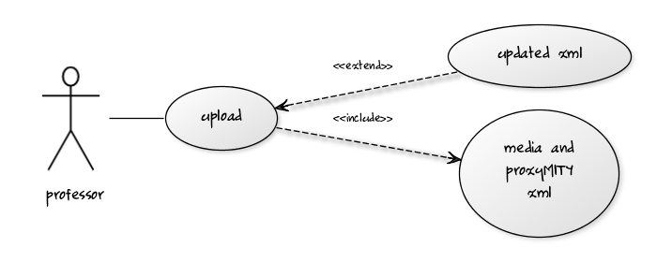

Use case view of the student:-

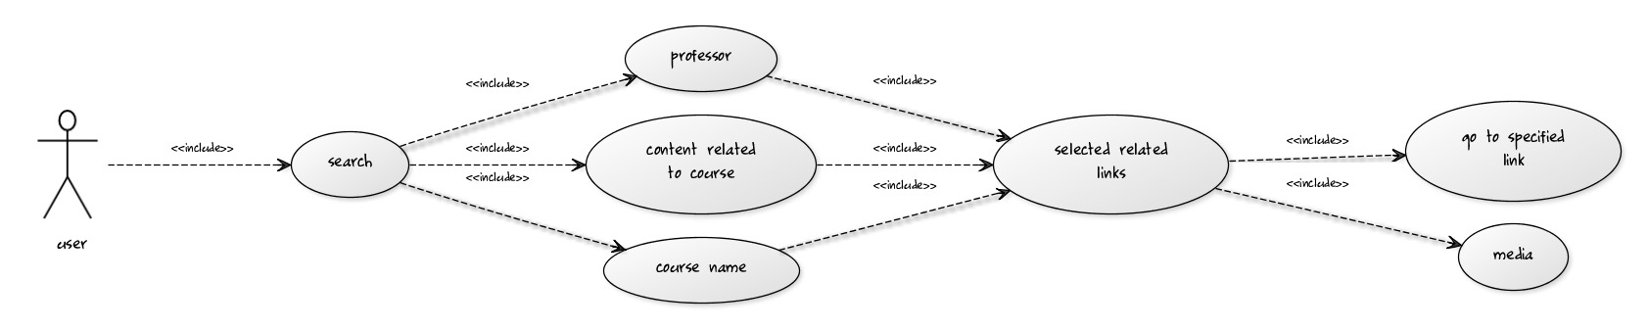

### 3.2.2 Actrivity Overview

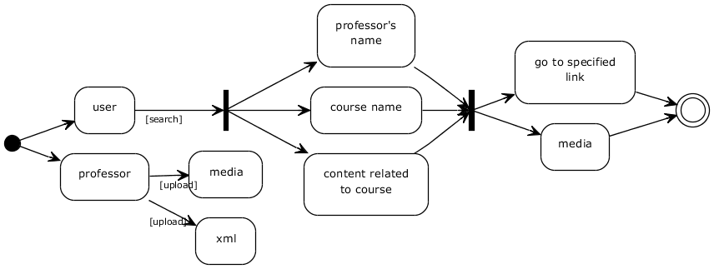

# Other Non-functional Requirements

**Maintainability:**Softwareneedstobeupgradedifrequiredinfuture.

**Reliability:**Systemmustbereliableanddatashouldpersistevenaftersufferingsome systemcrashesorbootingof android supported devices.

**Portability:**WeareusingHTML5tomakethe webapplicationmoreportableso that we can port on any platform.

**USER MANUAL**

**How to useproxyMITY on web?**

The search page of proxyMITYallows the user to search the published lecture video of his/her choice. For this the user need to enterkeyword related to either the name of the course, name of professor or any topic in a search box.

The search page is shown below in figure 1.

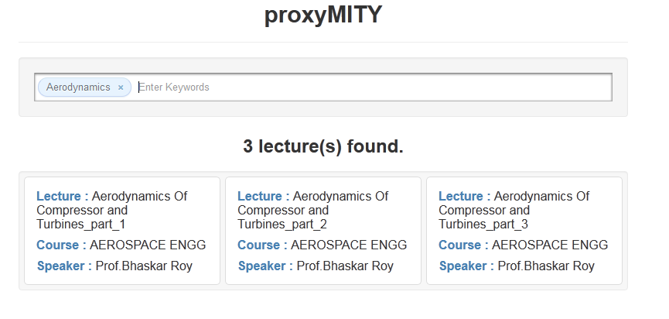

Figure 1

The text box shown at the top is used for searching the published lecture. He can enter the course name, professor name or any topic related to the course.

The search option field is shown in figure 2.

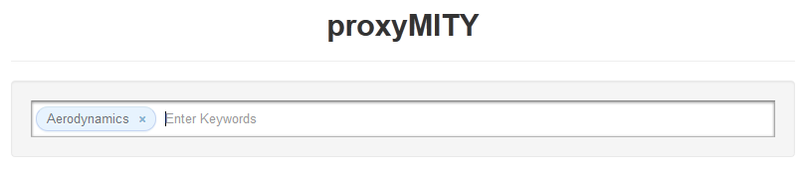

Figure 2

On searching for a particular lecture, the entirepublished lecture related to our search content will appear in the output box. On clicking any of the link/thumbnail of published lecture, it will redirect us to the page where lecture video and its lecture slides are running according to timeline information.

On clicking the search field, the page that will be displayed is shown in figure 3.

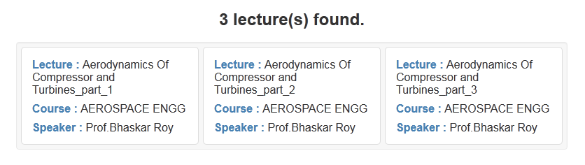

Figure 3

On clicking the thumbnail/link of the published lecture displayed in search box, we will be redirected to proxyMITY.

Figure 4 shows a lecture that is being viewed in proxyMITY.

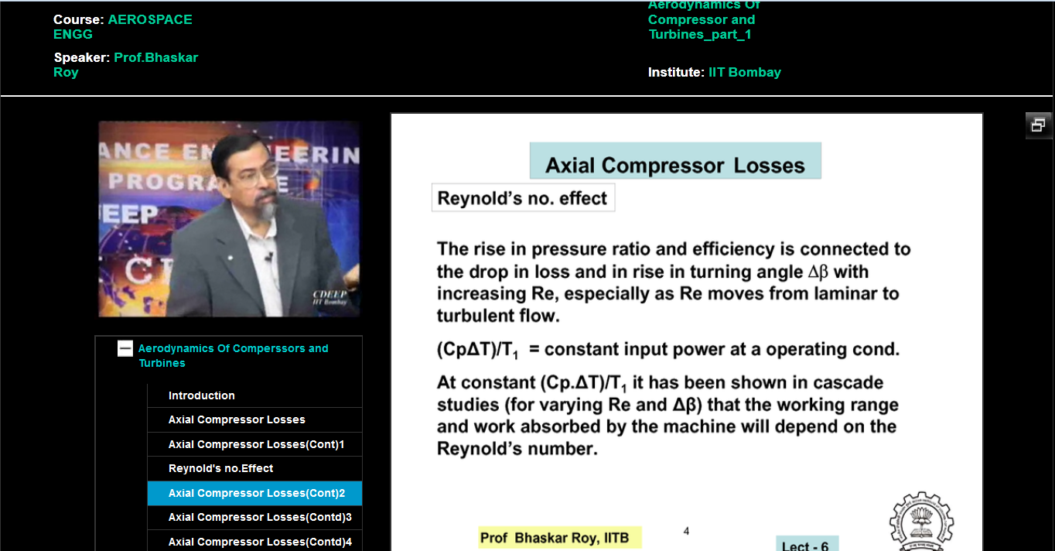

Figure 4

Figure 5 shows the published lecture with only video lecture ie without slides.

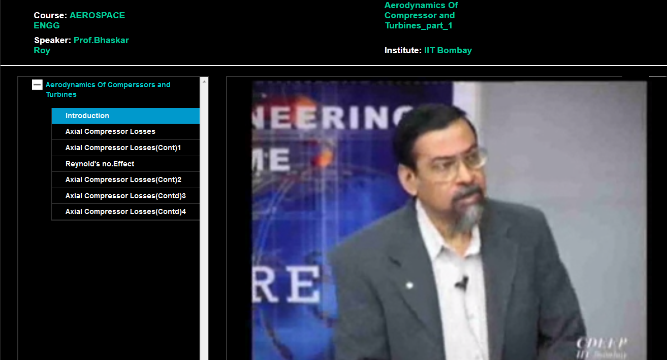

**Features of the web page:-**

The Web page includes the following features:

1. **Video Container:** Video Container shows the videoof the professor being played by the user. User can play, pause, forward backward the video according to its own wish. One can also full screen the video using the full screen option present on the bottom-leftcorner of the video. The video is included in the Web page using **video.js** plug-in.
2. **Tree Container:** Tree Container shows the list of all the topics covered by the professor during his lecture and also the corresponding slides.The plus and minus sign shown in the tree is used to expand and see the sub topics of the main topic. If a video is playing and in between he clicks on any portion of the tree then the video will jump at that particular location and also the slide will be changed to that corresponding slide.

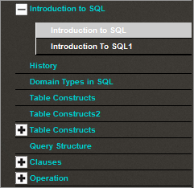

1. **Slides/Video Container:** Slide container shows the slides of the video which is playing at that moment. It also gets changed with the change in the video position.
2. **Enlarge Button:**This button is used to enlarge the size of the slide on the screen. As soon as the button is clicked, video and tree container gets hide and the slides get enlarged.

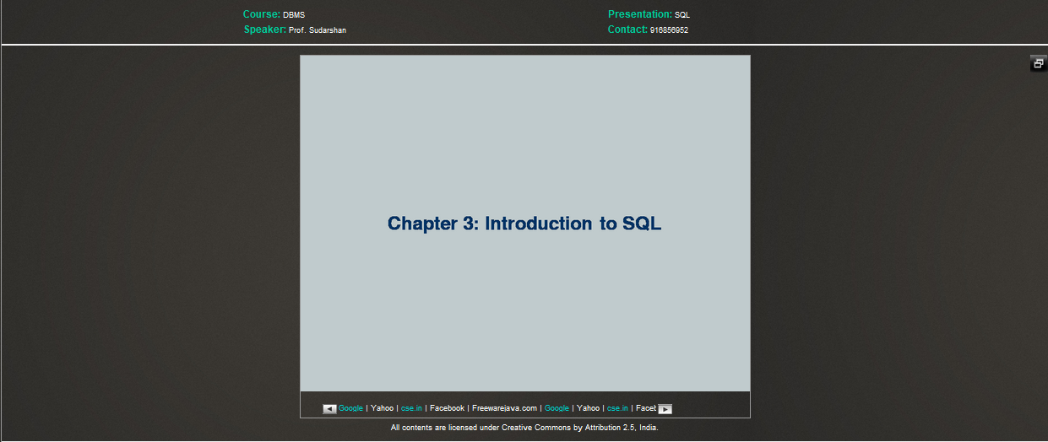

When that button is pressed again, it will again resize the size of the slide and both the video and tree container will appeared again on the screen.

1. **Links:** The links shown below the slides are used to reach on desired location on which the user clicks.

**C:\Users\dell\Contacts\Desktop\images proxymity\1234567.png**

**REFERENCES**

* 1. <http://ekalavya.it.iitb.ac.in/brochure.do>
  2. <http://www.roseindia.net>
  3. [http://www.roseindia.net/findtutorials/findtutorials.shtm](http://www.roseindia.net/findtutorials/findtutorials.shtml)
  4. www.w3schools.com/jquery/default.asp
  5. <http://java.sun.com/j2ee/tutorial1_3fcs/doc/JSPIntro.html>
  6. http://www.roseindia.net/jsp/jsp.html.